User Manual

Table of Contents

1. How to access payment functionality…………………………………………………2
2. How to access reminder functionality…………………………………………………4

Process for accessing payment functionality:

1. Log in as receptionist

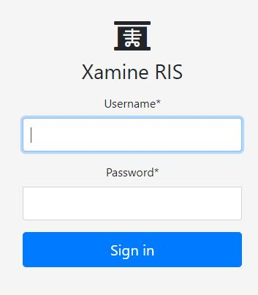

1. Select a completed order

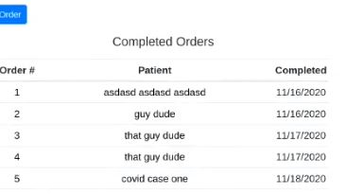

1. Scroll to the bottom of the page and click “Send patient invoice”

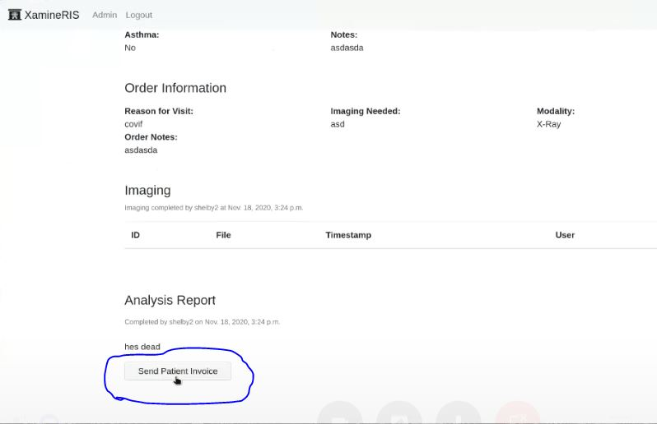

1. The patient will receive their invoice at the email that is on file, and an “Order complete” message will be displayed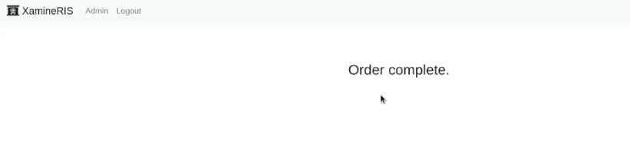

Process for accessing reminder functionality:

1. Login in as receptionist



1. Select a patient

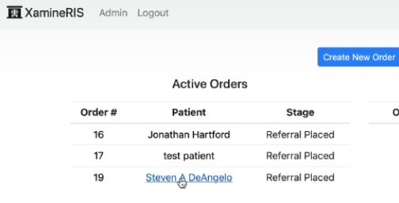

1. Click on schedule or reschedule button

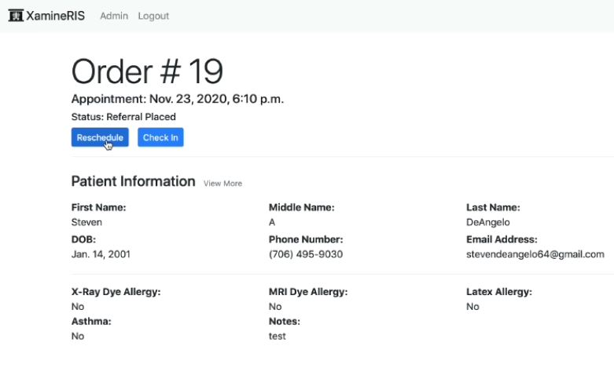

1. Schedule form will load

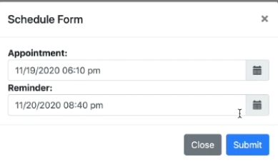

1. Input time or date for appointment and/or reminder
2. If there are no issues with the appointment or the reminder you will be redirected to a “success” page and an email will be sent the patient’s email that is on file

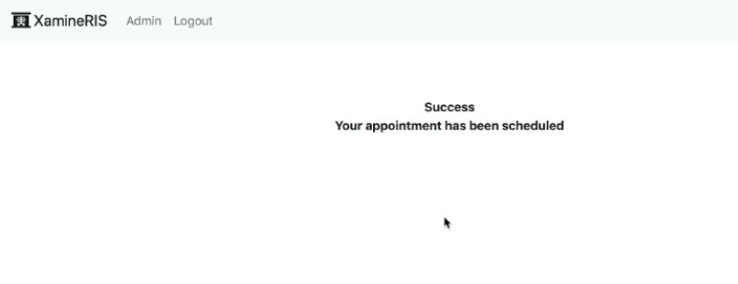

1. If the reminder is after the scheduled appointment time, then you will be redirected to an error screen, please go back and change the reminder time

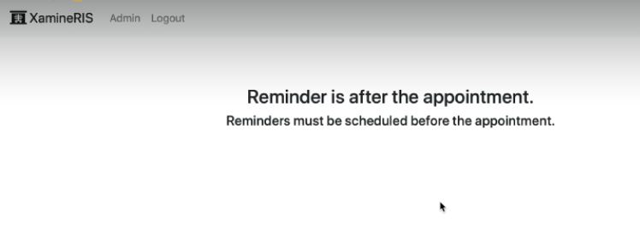

1. If an appointment is scheduled too near a time for another appointment then an error page will be displayed, please go back and change appointment time

